MEMORANDUM

TO: Ordinance Committee
FROM: Maureen O’Meara, Town Planner
DATE: February 10, 2011
SUBJECT: Growth Areas Review

Introduction

The Ordinance Committee began its review of growth areas at the January 19, 2011 meeting. Committee members requested additional information regarding amount of land in all the residential districts, a map showing land that has potential for more development and samples of different approaches to development. This information is further described below and included on the attached information.

What are Growth Areas?

Any land in town can be developed as long as the development complies with current regulations. For example, any property owner can create a lot in the RA District if the lot is at least 80,000 sq. ft. in size and has 125’ of road frontage. The lot can be built upon if there is a non-wetland area to locate construction and a septic system can be designed that complies with the Plumbing Codes.

Growth areas are locations that the Town has identified which can better absorb growth while preserving the town’s community character. If a town does not identify growth areas, growth will still occur based on market demands. Even if growth areas are identified, some growth will occur outside growth areas. Identification and implementation of growth areas directs market demand into the areas that a town has determined will still preserve community character.

Community character is a subjective determination made by a town, often formulated by public opinion surveys, and commonly articulated by “vision” statements. The 2007 Comprehensive Plan vision statement, recently reaffirmed by the Town Council, states:

The vision represented by this Comprehensive Plan is to preserve Cape Elizabeth as a highly desirable community in which to live by the following: expanding open spaces and accessible trails; encouraging the preservation of working farms; continuing the current slow pace and pattern of development; maintaining excellent educational and municipal services; cultivating the Town Center as a mixed use commercial area; supporting the high levels of citizen involvement in town activities; and balancing services and costs.

You might summarize Cape Elizabeth community character as predominantly defined by:

•Open Spaces (parks/farms/wetlands)
•Schools and Town services
•Town Center
•Volunteerism
•Yankee frugality

In recognition that market demand will result in some land development, a town may designate growth areas and then adopt policies that directs new development those locations. The amount of new development that actually is located in the growth areas rather than in other parts of town is influenced by the effectiveness of the development policies adopted by the town and the desires of private property owners.

Where are Cape Elizabeth’s Growth Areas?

The main growth areas in Cape Elizabeth are located in the RB District. The RB District was created in 1997 based on growth areas in the 1993 Comprehensive Plan. The RB District is composed of large (10 + acres) undeveloped lots. The RC District is considered an ”infill” growth area. Finally, the Town Center is considered a growth area. The Town Center, however, is predominantly commercial, so its ability to absorb residential development is limited, therefore its role as a growth area for residential development is minor.

The attached Zoning Map includes the location of the RB, RC and TC Districts.

RB District

The RB District is the largest amount of undeveloped land designated as a growth area. Attached are Aerial maps of the RB District and a list of lots located in the RB District.

New Growth and Capacity to absorb growth

The current Comprehensive Plan and land use regulations direct new growth into the RB District, RC District (infill) and Town Center (mixed use multi-family). The Ordinance Committee has asked for a comparison of regulations in the various districts, which is attached. Generally, the same amount of dwelling units can be accommodated on less land in the RC than in the RB and on less land in the RB than in the RA District. It should also be noted that subdivisions in the RB District must designate a minimum of 40% of the land area as permanently protected open space.

The 2007 Comprehensive Plan includes a build-out analysis in the Land Use Chapter. This analysis is a gross evaluation of build out by lot, applying current zoning regulations and estimating physical constraints and development efficiency. The build out analysis map is attached, and also includes outlines of the RB, RC and Town Center District.

Excerpt from the Comprehensive Plan:

Where might these new dwelling units be built? Is there enough room to accommodate this new growth? The Comprehensive Plan Committee conducted a build-out analysis using the town geographic information system. The analysis evaluated existing lots based on the level of development allowed under current zoning. Where lots are located in Sewer Service areas, a minimum lot size of 7,500 sq. ft. was used (the minimum lot size for clustered developments in the RC District).

Excluded from the land area calculation were wetlands depicted on the Official Zoning Map, floodplains and lots that are not vacant and are less than twice the minimum lot size. Town land or open space owned by the Land Trust, State of Maine or U. S. Government was also excluded. Lots that exceed twice the minimum lot size, even if there is a building on them, could still be considered developable land if sufficient land were available to create a second lot.

For the remaining land, a development efficiency ratio was also used. Vacant land typically cannot be developed at 100% of its density. The physical shape of the land, the need to build roads, etc. means some land will not be conveyed into minimum lot sized lots. The analysis took this into consideration by discounting the land area of any potentially developable parcel by 15% to 50%. An analysis for the Town of Falmouth found that subdivisions had an efficiency of 70%, private way developments an efficiency of 30%. The analysis assumed that development would be more efficient in the TC, BA and BB districts because those districts are more developed areas and would be engineered more compactly. Overall, the analysis was geared to generate a more conservative analysis of how much land is actually developable.

The build-out analysis indicated that approximately 1300 new housing units could potentially be accommodated on the remaining undeveloped land in Cape Elizabeth. Of the 1,300 units, approximately 390 are located on Sprague Corporation land and 42 are on the Purpoodock Golf Course. If these areas are removed, remaining land may maintain approximately 870 new dwelling units.

The Comprehensive Plan Committee used the build-out analysis map and the projected dwelling units to identify the growth areas through the year 2020. The Committee identified 11 lots where they recommended that 10 or more units be constructed in order to reduce the need for development of more land town-wide. The committee identified approximately 90 individual existing lots that would be available for infill development. The conclusions of the proposed build-out were then compared to current zoning provisions. In most cases, existing land use policies facilitated the committee’s recommendations. Some adjustment and fine-tuning of density and public sewer will be needed to achieve goals of clustering.

Cape Elizabeth has approximately 518 acres of undeveloped land in the RB District, the zoning designation for growth areas. If the current zoning density is maintained, and assuming a development efficiency rate of 50%, the undeveloped RB land could accommodate 376 new units. Based on the projected growth of 330 units between 2007 and 2020, the existing growth areas should be sufficient to absorb new growth and designation of additional growth areas will not be necessary. In addition, some infill growth is expected to be accommodated in the RC and in or adjacent to existing neighborhoods. If the RB District density is increased, the amount of land currently zoned RB may be sufficient to absorb new growth through the year 2030 without designating new growth areas.

The Ordinance Committee asked for a build-out analysis broken down into the residential districts. See below.

District Potential New units Developable Area (acres)

RA 650 2300
RB 100 400
RC 370 200
TC 40 10

How does development look in different districts?

New development in the RC and RB Districts looks different that development in the RA District. Even more striking, however, is the difference between a clustered/Open Space Zoning Subdivision and a Traditional Subdivision. Attached are two examples.

The first example is two adjacent neighborhoods located in the RC on 25 acres of land. The first is a 1960’s subdivision where 1 acre of open space was preserved. The second is a modern subdivision plan where 12 acres were preserved. Which development has more units? The densities in both are almost identical. The second subdivision also creates less impervious surface to generate runoff and less linear miles of road for the town to maintain than the first neighborhood.
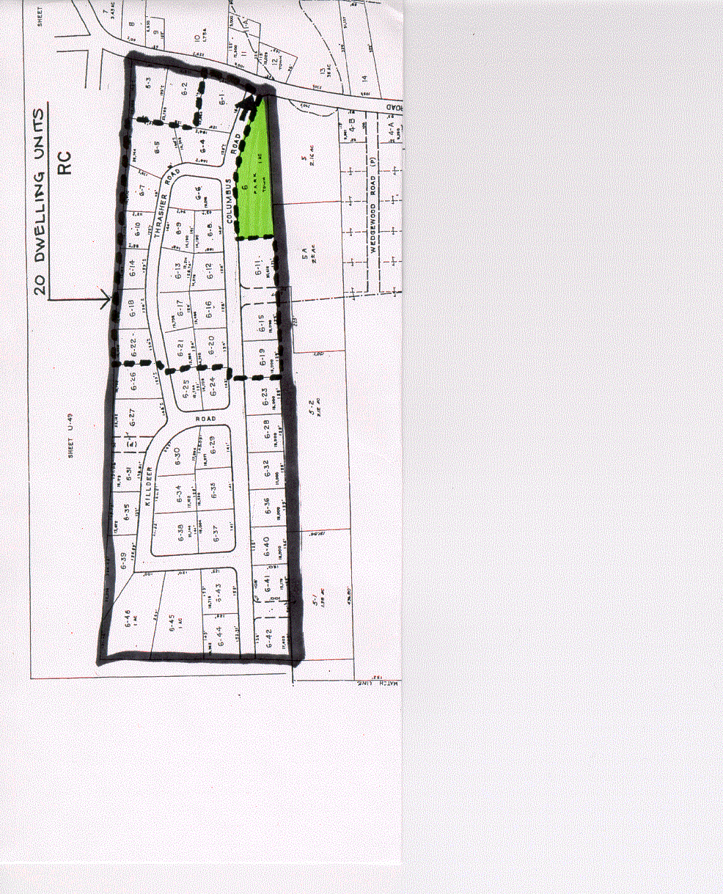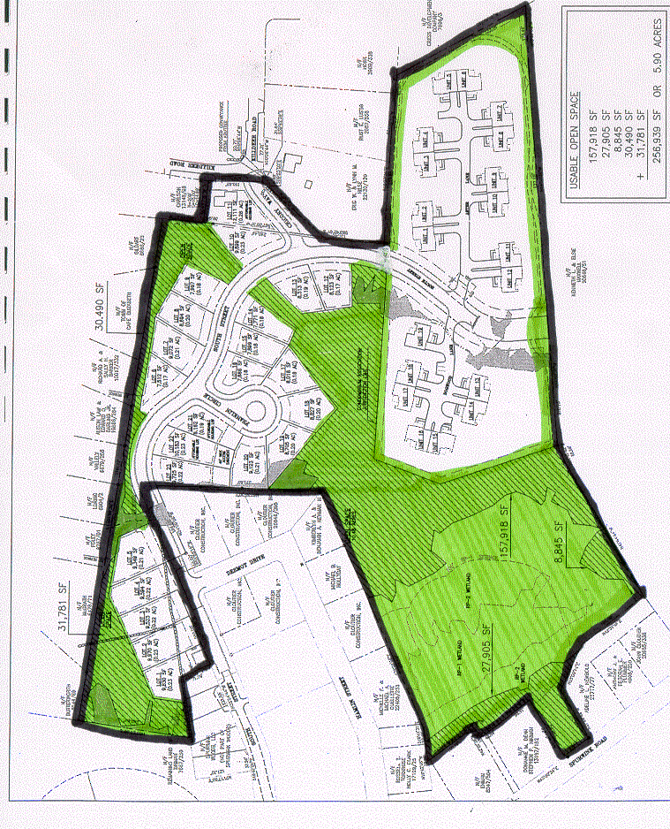

The second example is a project recently approved in Sidney, Maine, but the land easily resembles land in Cape Elizabeth. The first example is a rough approximation of what a traditional subdivision in the RA District would look like. The second is the approved project in Sidney. The yellow is the preserved open space and the green areas are wetlands protected from development.

